## PART 1: gzip – File Compression

### Tasks
- Create a text file named `logfile.txt`.
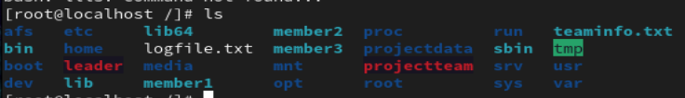
- Add some content to `logfile.txt`.
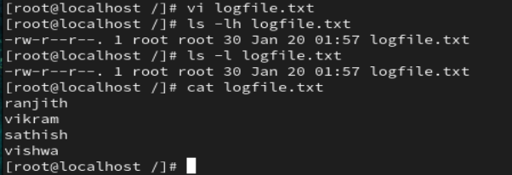
- Compress `logfile.txt` using gzip.
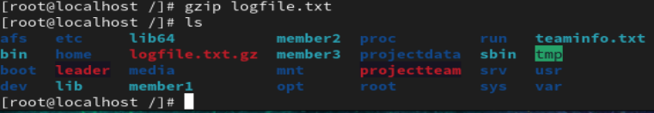
- Verify that the original file is replaced with a compressed file.

- Check the file size before and after compression.
- Decompress the gzip file and restore the original file.
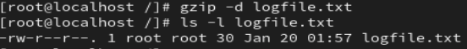
- Verify the contents after decompression.
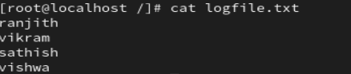

---

## PART 2: Multiple File Handling with gzip
### Tasks
- Create three files named `file1.txt`, `file2.txt`, and `file3.txt`.
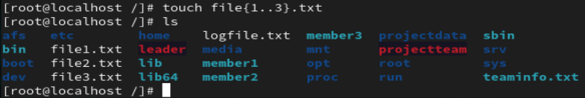
- Compress each file using gzip.
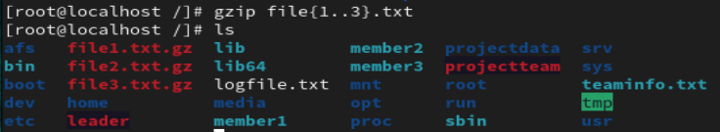
- Verify that each file is compressed individually.
- Decompress all compressed files.
- Confirm that all original files are restored.
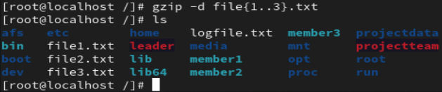

---

## PART 3: zip – File and Directory Compression
### Tasks
- Create a directory named `project`.
- Create multiple files inside the `project` directory.
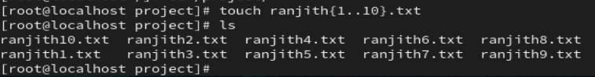

- Compress the `project` directory into a zip file.
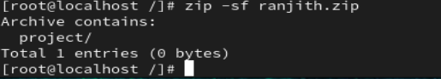
- Verify that the zip file is created successfully.
- List the contents of the zip file without extracting it.
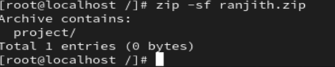
- Extract the zip file into a new directory.

- Verify the extracted files and directories.
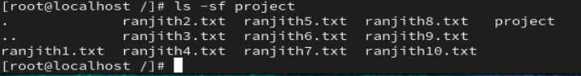

---

## PART 4: tar – Archiving Files
### Tasks
- Create a directory named `backupdata`.
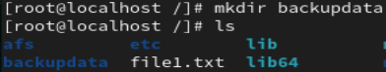
- Create files inside the `backupdata` directory.
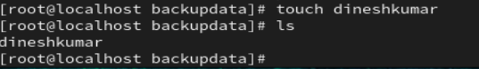
- Create a tar archive of the `backupdata` directory.
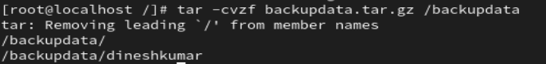
- Verify that the tar archive is created.
- List the contents of the tar archive.
- Extract the tar archive into a new location.
- Verify the extracted data.
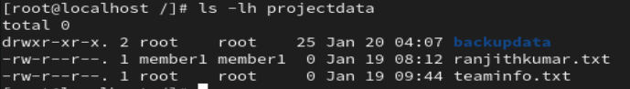

---

## PART 5: tar with Compression (Real-Time Backup Scenario)

### Tasks

- Create a compressed tar archive of the `backupdata` directory.
- Verify the size difference between normal tar and compressed tar.
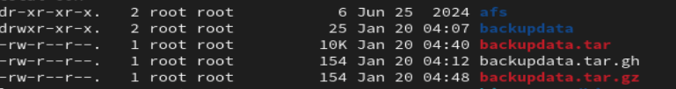
- Extract the compressed tar archive.
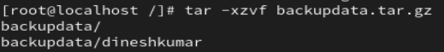
- Verify file integrity after extraction.
